SUPPLY CHAIN ANALYSIS

End-to-End Data Analysis and Late Delivery Risk Modeling

1. Executive Summary
This project analyzes a supply-chain transaction dataset using Python and Jupyter Notebook. The analysis focuses on delivery performance, delay behavior, profitability, bottleneck detection, root-cause analysis, time-based patterns, and machine-learning prediction of late-delivery risk.
The notebook contains 180,519 records and 53 original columns. After feature selection and removal of operationally unnecessary or sensitive fields, the working dataset contains 21 columns before additional analytical features are created.

2. Project Objectives
- Understand the structure and quality of the supply-chain data.
- Clean the dataset and remove fields that are not required for the analysis.
- Measure order processing time and delivery delay.
- Analyze profitability in relation to delivery performance.
- Identify potential supply-chain bottlenecks and root causes of delays.
- Study delay patterns by month, day of week, and hour.
- Build a Random Forest model to predict late-delivery risk.

3. Dataset Overview
Metric | Notebook Result
Rows | 180,519
Original columns | 53
Duplicate rows | 0
Source file | DataCoSupplyChainDataset.csv
Customer countries represented | EE. UU. and Puerto Rico
Main customer segments | Consumer, Corporate, Home Office
Shipping modes | Standard Class, Second Class, First Class, Same Day
The notebook reports no duplicate rows. The largest missing-value counts in the original data were Product Description (180,519) and Order Zipcode (155,679).

4. Data Cleaning and Preparation
The notebook removes fields that are not needed for the analytical objectives, including:
- Product description and product image fields
- Customer email, password, names, street, and zipcode fields
- Order/customer identifiers that are not required for the analysis
- Latitude and longitude
- Several item-level identifier, discount, quantity, and total fields
- Product status and geographic fields removed by the notebook
The notebook also removes records where Delivery Status equals 'Shipping Canceled' and converts the order and shipping date columns to datetime.
Analytical features created include Order Processing Time, Delay, Is_Delayed, order_month, order_day, and order_hour. A Profitability Flag is also created from Order Profit Per Order.

5. Exploratory Data Analysis
The notebook examines categorical distributions, descriptive statistics, shipping performance, profitability, and delay behavior.
- Payment/transaction Type: DEBIT 69,295; TRANSFER 49,883; PAYMENT 41,725; CASH 19,616.
- Shipping Mode: Standard Class 107,752; Second Class 35,216; First Class 27,814; Same Day 9,737.
- Customer Segment: Consumer 93,504; Corporate 54,789; Home Office 32,226.
- Delivery Status includes Late delivery, Advance shipping, Shipping on time, and Shipping canceled.
- Mean real shipping time is about 3.50 days, compared with about 2.93 scheduled days.
- Mean Sales per customer is about $183.11 and mean Order Profit Per Order is about $21.97.

6. Profitability Analysis
The notebook classifies each record as Profit, Loss, or Break-even using Order Profit Per Order.
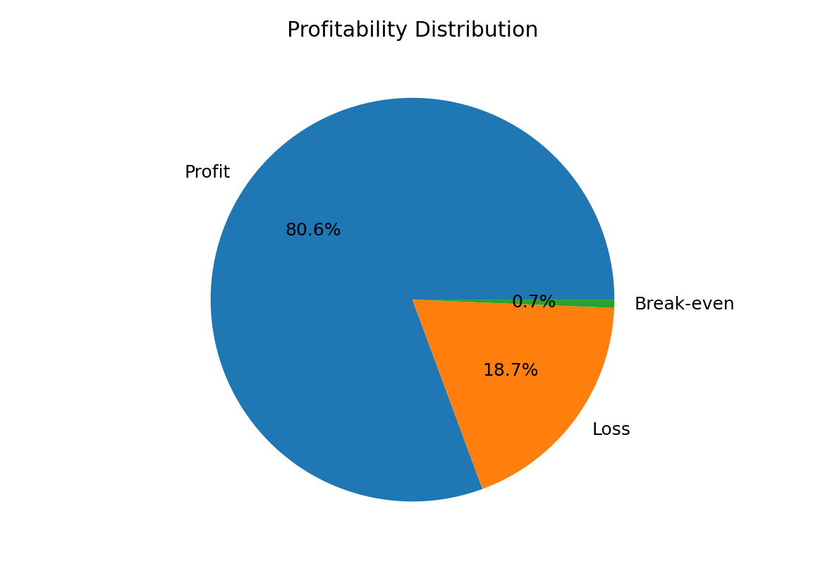
Figure 1. Profitability distribution derived from the notebook output.
Category | Records | Approx. share
Profit | 145,558 | 80.6%
Loss | 33,784 | 18.7%
Break-even | 1,177 | 0.7%

7. Business KPIs
KPI | Notebook result
Total orders | 180,519
Late deliveries identified by Delay > 0 | 13,807
On-time delivery | 92.4%
Late delivery | 7.6%
Total profit from positive-profit records | $7.9M
Notebook-reported 'Total Loss due to delays' | $290.5K
Important reporting note: the notebook labels $290.5K as 'Total Loss due to delays', but the code actually sums Order Profit Per Order for records where Delay > 0. Therefore, this figure should be described as profit associated with delayed records rather than a separately calculated monetary loss caused by delays.

8. Profitability vs Delivery Time
The notebook groups Order Profit Per Order by Delay. The results show that average profit varies across delay levels. The largest number of records in this analysis occurs at a 1-day delay.
- 1-day delay: 5,945 records with mean profit of about $21.97.
- 2-day delay: 5,472 records with mean profit of about $18.49.
- 0-day delay: 3,579 records with mean profit of about $22.01.
- 3-day delay: 1,098 records with mean profit of about $25.04.

9. Delay Distribution
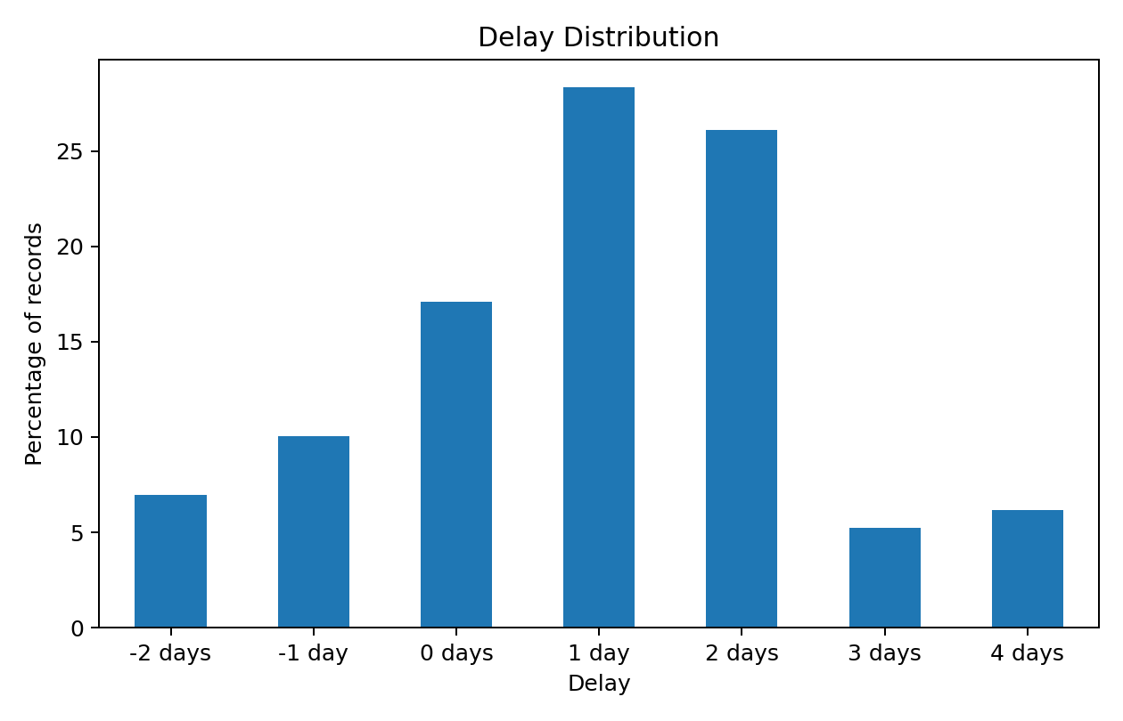
Figure 2. Delay distribution based on the notebook's derived Delay feature.
The notebook reports that 166,712 records are not flagged as delayed by the derived Is_Delayed field, while 13,807 records are flagged as delayed.

10. Bottleneck Detection and Root Cause Analysis
The notebook includes dedicated sections for 'BottleNeck Detection' and 'ROOT CAUSE ANALYSIS'. The analysis is designed to calculate delay percentages by category and identify drivers of late delivery for regions. These sections should be used to support operational recommendations.
Because the notebook output supplied here does not expose every ranked category/region result in text, this report does not invent a specific top-performing or worst-performing category/region.

11. Time-Based Analysis
The notebook creates order_month, order_day, and order_hour and analyzes delay percentage by month, day of week, and hour. This is useful for identifying periods where operational capacity or fulfillment processes may need additional attention.

12. Machine Learning: Late Delivery Risk
The notebook develops a Random Forest Classifier for the Late_delivery_risk target. The training data is balanced so that the two target classes have equal representation in the training set.
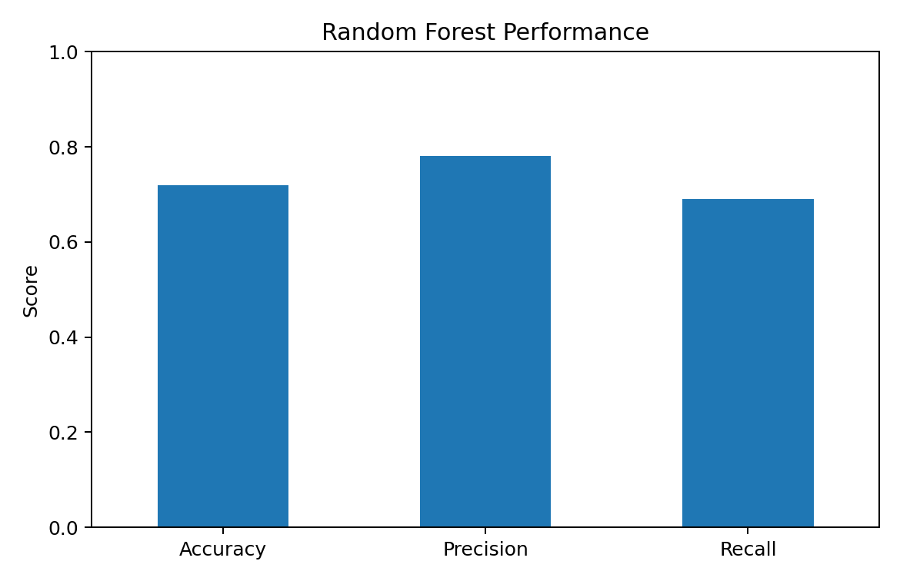
Figure 3. Random Forest performance metrics reported by the notebook.
Metric | Score
Accuracy | 0.72
Precision | 0.78
Recall | 0.69
The classification report also reports class-level precision, recall, and F1 scores. Overall accuracy is 72%, with precision of 78% and recall of 69% for the late-delivery class.

13. Key Findings
- The dataset is large, with 180,519 supply-chain records, and contains no duplicate rows.
- Delivery performance is a central issue: the derived analysis identifies 13,807 delayed records.
- The notebook reports 92.4% on-time delivery and 7.6% late delivery using its Delay-based KPI definition.
- Standard Class is the most common shipping mode in the dataset.
- Consumer customers form the largest customer segment.
- Most records are classified as profitable, while a smaller portion is classified as loss or break-even.
- The relationship between delivery delay and profit is not simply linear; different delay levels show different average profits.
- The Random Forest model provides a baseline predictive model for late-delivery risk with 72% accuracy.

14. Business Recommendations
- Monitor delayed orders proactively and prioritize cases with increasing delay.
- Investigate the operational causes behind the largest delay-producing categories and regions identified by the notebook.
- Use the time-based delay analysis to plan staffing and fulfillment capacity during higher-risk periods.
- Track shipping mode performance separately to identify opportunities for improving service reliability.
- Use the late-delivery prediction model as a baseline decision-support tool and improve it with additional validated features if required.
- Monitor profitability alongside delivery performance so that service improvements do not create unintended margin pressure.

15. Limitations and Data Quality Notes
- A large number of original fields contain missing values, especially Product Description and Order Zipcode.
- Order and shipping dates have substantial missingness in the working dataset; derived processing-time metrics are therefore available only where both dates are present.
- The notebook's '90% Delay (days): 3.0%' output is formatted as a percentage even though the underlying metric is a 90th-percentile delay in days. It should be reported as approximately 3 days.
- The notebook's '$290.5K Total Loss due to delays' label does not calculate incremental loss caused by delays; it sums profit values for delayed records.

16. Conclusion
This Supply Chain Analysis project demonstrates an end-to-end analytical workflow in Python: data loading, data cleaning, feature engineering, exploratory analysis, KPI development, delay and profitability analysis, bottleneck/root-cause investigation, time-based analysis, and machine-learning classification. The project is suitable for a data-analytics portfolio because it connects technical analysis with operational business questions.

17. Portfolio Usage
For GitHub, include the original notebook, a cleaned dataset only if redistribution is permitted, a README, and selected dashboard/chart images. For LinkedIn, highlight the business problem, the tools used, the major KPIs, the machine-learning result, and 2–3 visualizations.

